BC Diesel Flash Tool Instructions
BC Diesel aftermarket calibrations are installed by our touch screen hand-held programmer. Below are step by step instructions for installing the software on a PC and using all the tool’s capabilities.
If you have Windows 8 / 8.1, please follow instructions in Appendix B to disable Driver Signature Enforcement.
- The latest version of User Software is located at the link below. After the link opens, start the download by clicking on the down arrow with the line beneath it in the upper, right side of window.
https://drive.google.com/file/d/1_AsdxcVDFuJnWaVEXxB4AdG2JIeSHvCE/view?ts=5f68e9ae
- Make sure your computer is connected to the internet and then launch the user console installer. Select “continue” for any windows compatibility messages. Right-click on the flash scan icon on the desktop, select “run as administrator”. This prevents random error messages.

- Once the installation is finished the software will open and a message box will be present prompting you to connect the device. Perform this step using the supplied USB cable. Please note: The software will now automatically update itself with the latest contents, so it is necessary that your internet connection is active. Depending on its speed and the updates required, this step could take up to 20 minutes.
- Once the updates are complete, the user console main screen will be present:
- At this point the program can be closed and the tool disconnected from the PC.
- Using the supplied tool-to-OBD cable, connect the Flash-Scan 3 tool to your vehicle’s Diagnostic Port connector making sure that the ignition is in the run position (all lights on the dashboard should be lit up). Do not start the engine.
NOTE: If you have a 2018 model year Ram or Jeep vehicle, the Security Gateway Bypass must be installed before you can proceed with the tuning process.

- After connecting to the car, the tool will boot up and is now ready to read out the stock ECU calibration. Select the “Tuning” menu in the upper left-hand corner and follow the on-screen instructions to select your appropriate manufacturer and model. Sometimes the vehicle type on the tool might not match to the exact model of your vehicle, so please reference the below table for vehicle type selection in these cases:

Your vehicle type… | Flash tool menu selection
2005-2006 Liberty CRD | Jeep -> Liberty -> 2.8L 161hp
2002 – 2006 Mercedes Sprinter (all with 2.7L engine) | Mercedes -> Sprinter -> W905 2700 OM612 156hp
2007 – 2008 Mercedes Sprinter (all with 3.0L engine) | Mercedes -> Sprinter -> W906 3000 OM642 184hp
2007 – 2008 Jeep Grand Cherokee | Jeep -> Commander -> 3.0L V6 CRD
2014 – 2019 Ram 1500 EcoDiesel Engine  2014 – 2018 Jeep Grand Cherokee Engine | Dodge -> Ram 1500 -> 3.0 V6 EcoDiesel, 2nd entry (Bosch EDC17C79 at bottom of screen)
2014 – 2019 Ram 1500 EcoDiesel Transmission  2014 – 2016 Jeep Grand Cherokee Transmission | Dodge -> Ram 1500 -> 3.0 V6 EcoDiesel, 1st entry (ZF 8HP70 at bottom of screen)

Once the vehicle has been correctly selected, Press the Right arrow at bottom of screen. The tool will give a message “Stock File Empty: Continue to Read ECU?”. Select YES to continue reading the stock file from the vehicle and follow the on-screen prompts.

In some cases, the touch screen does not respond easily or is otherwise clearly not responding to inputs in the correct location. If this happens, the touch screen needs to be recalibrated. To perform this process, please reference the instructions in Appendix C.

2
- After the read operation is completed with the tool, reconnect the flash tool to your PC and open the user console. Select the option “Download Data” and click “START” in the main window. Do not select the “download LOG” option, as it will not create the proper file.
When the operation is complete, save the file on your desktop with the name as indicated: FirstName_LastName_VehicleType.usr

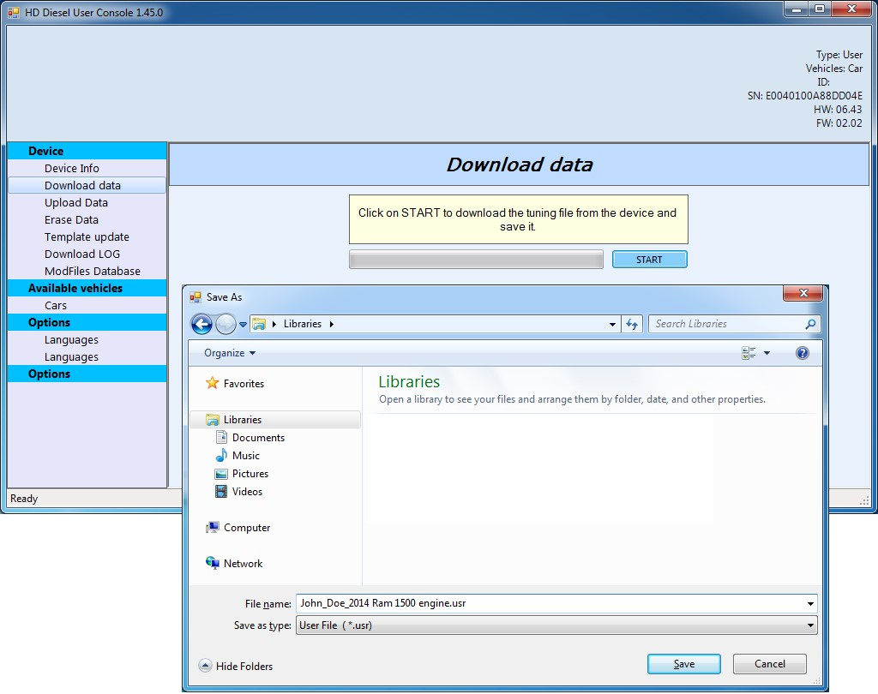

- Email the file you just saved to BC Diesel Truck Repair: mark@bcdiesel.ca

- You will receive back a file named: FirstName_LastName_VehicleType.usr
This file can be saved anywhere on your PC, we recommend in the same directory as the file obtained in step 8.

- Reconnect the flash tool and open again the user console software. Choose the option “Upload Data” and then click the “BROWSE” button to select the file received in step 10.
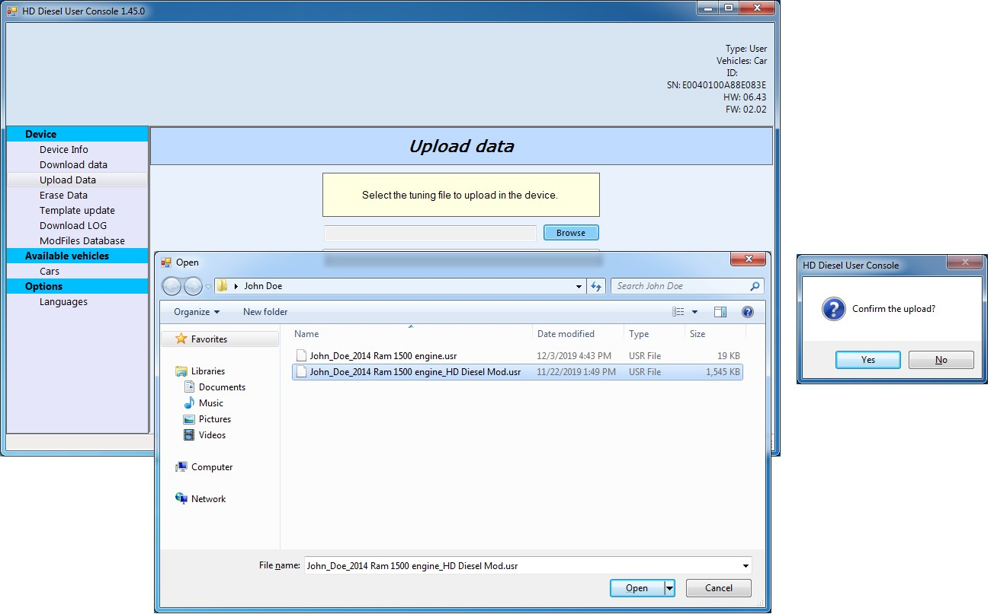

When the upload is completed, a message will appear indicating “Data has been written.”

- The user console software can now be closed, and the tool disconnected from your PC.

- Return to your vehicle with the flash. Turn the ignition to the “RUN” position as before and then reconnect the tool to your diagnostic port. Make sure to not start the engine.

- Select the “TUNING” menu in the upper left-hand corner of the screen. A prompt will appear asking if you want to continue with the writing of the file: select YES.

- A screen will now appear showing the available tunes. There will be at top the Original File (stock tune) and one or more modified versions will be available. Select the appropriate tune you wish to flash and then select the right arrow to begin the process. The Liberty CRD can take 30 minutes to flash, all others within 8 minutes.

- Once the operation is completed, you are ready to begin enjoying your newly-tuned vehicle!
Please note that the Flash/Scan 3 tool is locked to the VIN of your vehicle once the modified file is written to the ECU. The tool can then only be used with that VIN and ECU serial number. Before going to a dealer make sure to always flash back the Original file as this unlocks the tool.

Appendix A: What to do in case of tool errors
In 99% of all circumstances, the flash tool works without any issues to you the customer. However, in case of an error during the reading and/or writing, or for any other errors the tool might have, the below steps will help you to send us the necessary information for further support.

- Connect the flash tool to your PC and then open the user console software.
- In the left side menu, click on “Download LOG” and then in the main window click “START”.
When the “Save As…” window appears, please save the file with the name in the indicated format:
<First Name>_<Last Name>_<Type of Vehicle>_FlashToolLog_<Date>.usrlog
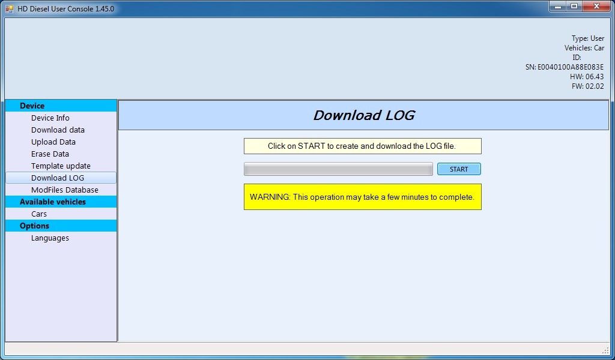

- Email the user log file to: <insert contact email address here> for processing and feedback.

Appendix B: Windows 8 / 8.1 – Disable Driver Signature Enforcement
- Hold down the Windows key on your keyboard and press the letter C to open the Charm menu, then click the gear icon (Settings).
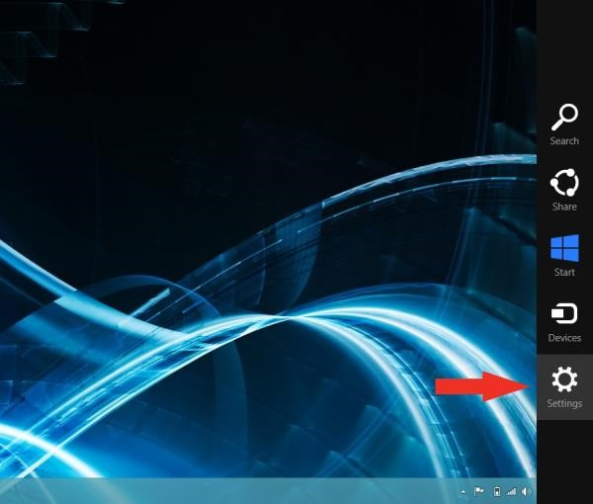

- Click More PC Settings
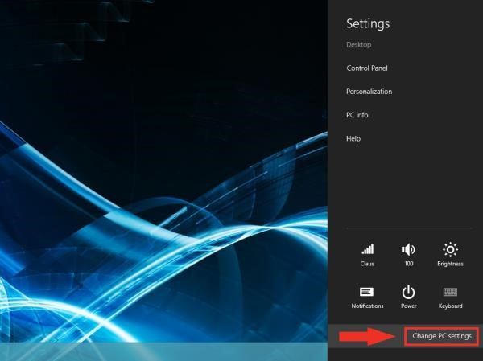
- Click General
- Windows 8: Under Advanced Startup, click Restart Now
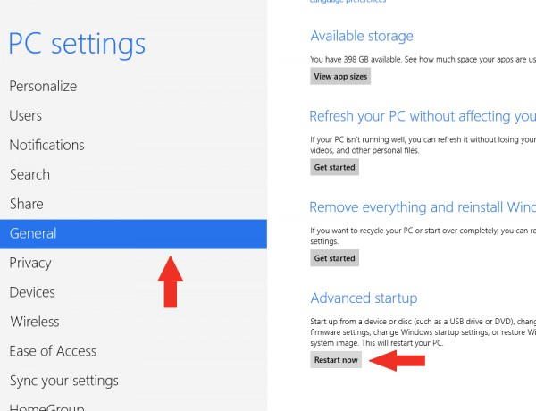

Windows 8.1: Change PC Settings -> Update & Recovery -> Recovery -> Restart Now

- After your computer restarts, click Troubleshooting
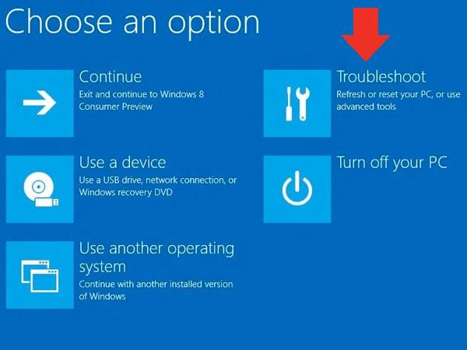
- Click Advanced Options
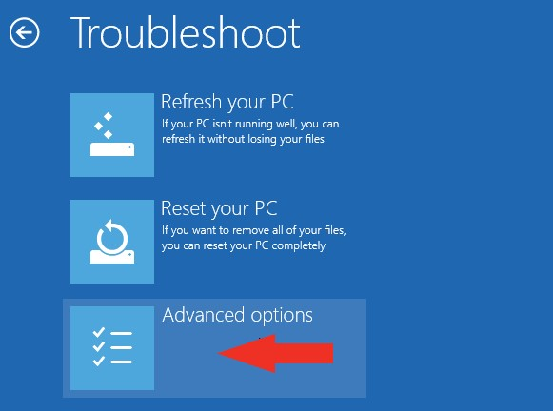

- Click Startup Settings
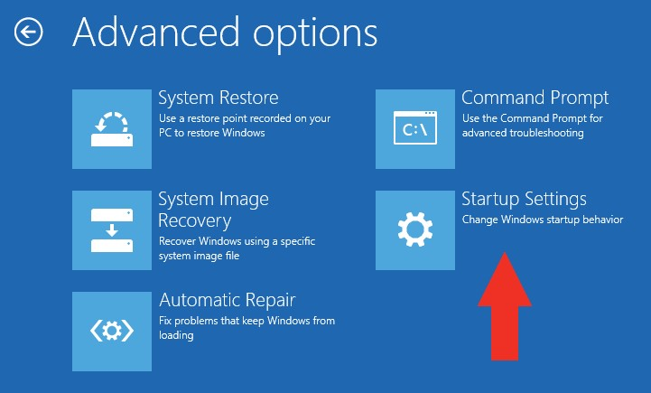

- Click Restart
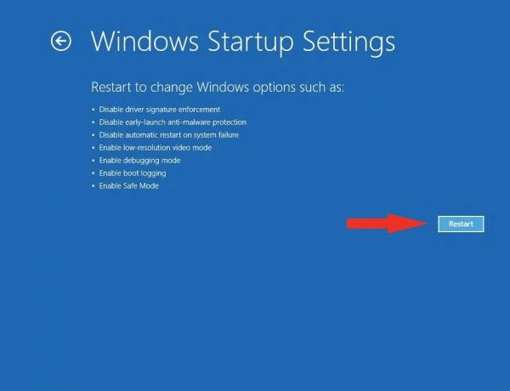

- After restarting your computer a second time, choose Disable driver signature enforcement from the list by typing the number 7 on your keyboard.
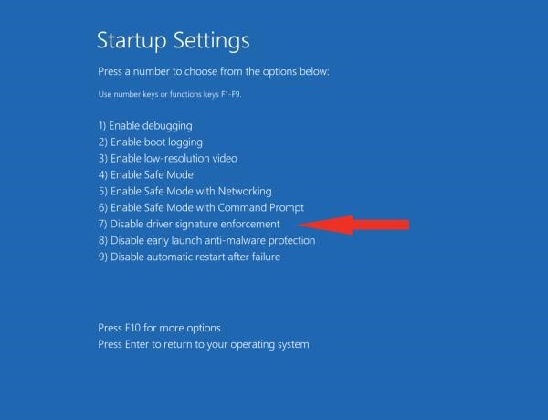
- After restarting, you can proceed to install the GDE Flash-Scan 3 Console software. You might see the below message box indicating that Windows cannot verify the publisher of the drivers. Please click Install This Driver Software Anyway in order to continue the installation process.
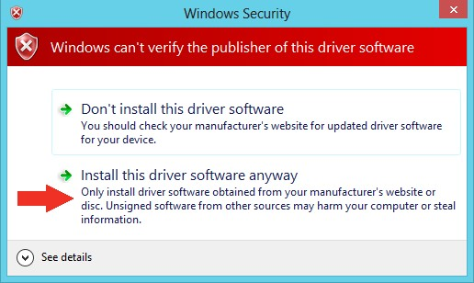

Appendix C: Touch Screen Recalibration

- Connect the tool to the OBD port of your vehicle so it turns on
- Select the SETUP menu in upper right hand corner of the main screen
- Select the CALIBRATION menu in upper right hand corner
- Follow the on-screen prompts to complete the recalibration process. It is best to use a ball-point pen or similarly shaped object to touch the small square box as it moves along the screen.
- If the process completes successfully then it will return you to the SETUP menu screen, press the BACK button to return to the home menu and continue with your original task.

Appendix D: How to Read/Clear Codes with the BC Diesel Flash Tool

- Connect the tool to the OBD port and make sure the key is in the RUN position.

- Select the DIAGNOSIS option from the main screen

- Select the MY VEHICLE option

- After selecting My Vehicle, a window will appear for the reading of the DTC Codes. Make sure DTC CODES is highlighted and click the Right arrow at bottom right corner of the screen.

- When the right arrow is selected, the Flash/Scan 3 tool will query the engine controller for any codes. If any codes are present a window will appear listing the code numbers. To clear the codes select the YES option.

If no codes are present the tool will inform you of such and then you can return to the main screen.

